**Home Work**

Write a program that simulates inventory bins in a warehouse. Each bin holds a number of the same type of parts. The program should use a structure that keeps the following data:

**Description of the part kept in the bin**

**Number of parts in the bin**

The program should have an array of 10 bins, initialized with the following data:

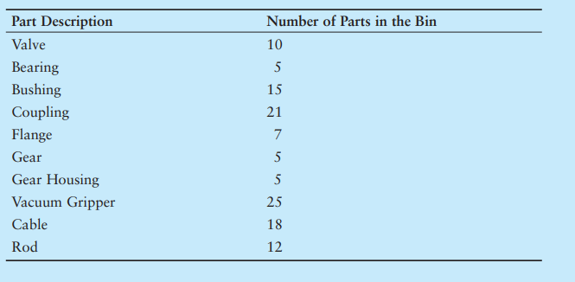

The program should have the following functions:

**AddParts**: a function that increases a specific bin’s part count by a specified number.

**RemoveParts**: a function that decreases a specific bin’s part count by a specified number.

When the program runs, it should repeat a loop that performs the following steps: The user should see a list of what each bin holds and how many parts are in each bin. The user can choose to either quit the program or select a bin. When a bin is selected, the user can either add parts to it or remove parts from it. The loop then repeats, showing the updated bin data on the screen.

**Input Validation:** *No bin can hold more than 30 parts, so don’t let the user add more than a bin can hold. Also, don’t accept negative values for the number of parts being added or removed*.

**END**